**Question 01**

class Example{

public static void main(String args[]){

System.out.println("Darshana Pubudu Keerthirathna");

}

};

K:\projects\MY_PROJECTS\ICM106\Programming Fundamentals\week_02\Assignment_02\01>java Example

Darshana Pubudu Keerthirathna

**Question 02**

class Example{

public static void main(String args[]){

System.out.println("Darshana Pubudu Keerthirathna");

System.out.println("15,");

System.out.println("Tilton Housing Scheme,");

System.out.println("Pallegama");

System.out.println("Nawalapitiya");

System.out.println("keerthi.mac@gmail.com");

System.out.println("0716521436");

}

}

K:\projects\MY_PROJECTS\ICM106\Programming Fundamentals\week_02\Assignment_02\02>java Example

Darshana Pubudu Keerthirathna

15,

Tilton Housing Scheme,

Pallegama

Nawalapitiya

keerthi.mac@gmail.com

0716521436

**Question 03**

class Example{

public static void main(String args[]){

System.out.println("*");

System.out.println("* *");

System.out.println("* * *");

System.out.println("* * * *");

}

}

K:\projects\MY_PROJECTS\ICM106\Programming Fundamentals\week_02\Assignment_02\03>java Example

*

* *

* * *

* * * *

**Question 04**

class Example{

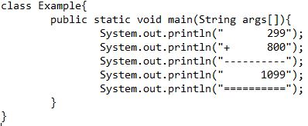 public static void main(String args[]){

System.out.println(" 299");

System.out.println("+ 800");

System.out.println("----------");

System.out.println(" 1099");

System.out.println("==========");

}

}

K:\projects\MY_PROJECTS\ICM106\Programming Fundamentals\week_02\Assignment_02\04>java Example

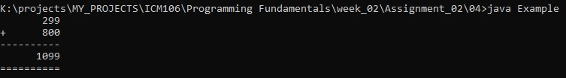 299

+ 800

----------

1099

==========

**Question 05**

class Example{

public static void main(String args[]){

System.out.print("* * * * * *");

System.out.println(" ==================================");

System.out.print(" * * * * * ");

System.out.println(" ==================================");

System.out.print("* * * * * *");

System.out.println(" ==================================");

System.out.print(" * * * * * ");

System.out.println(" ==================================");

System.out.print("* * * * * *");

System.out.println(" ==================================");

System.out.print(" * * * * * ");

System.out.println(" ==================================");

System.out.print("* * * * * *");

System.out.println(" ==================================");

System.out.print(" * * * * * ");

System.out.println(" ==================================");

System.out.print("* * * * * *");

System.out.println(" ==================================");

System.out.println("==============================================");

System.out.println("==============================================");

System.out.println("==============================================");

System.out.println("==============================================");

System.out.println("==============================================");

System.out.println("==============================================");

}

}

K:\projects\MY_PROJECTS\ICM106\Programming Fundamentals\week_02\Assignment_02\05>java Example

* * * * * * ==================================

* * * * * ==================================

* * * * * * ==================================

* * * * * ==================================

* * * * * * ==================================

* * * * * ==================================

* * * * * * ==================================

* * * * * ==================================

* * * * * * ==================================

==============================================

==============================================

==============================================

==============================================

==============================================

==============================================

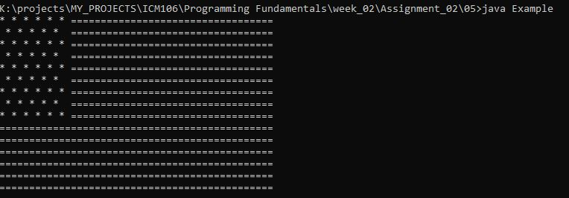

**Question 06**

**Program A**

K:\projects\MY_PROJECTS\ICM106\Programming Fundamentals\week_02\Assignment_02\06>java Example

Institute of Computer Engineering Technology

223 A,

Galle Road,

Panadura.

**Program B**

K:\projects\MY_PROJECTS\ICM106\Programming Fundamentals\week_02\Assignment_02\06>java Example1

Institute of Computer Engineering Technology

223 A,Galle Road,Panadura.

**Question 07**

Generally we use println() & print() both to print something in console. But key difference is if we use println() after this function executes, curser goes to new line. If we use print(), it dose not start with new line but curser start next to previously printed line.

println() – curser start with new line

print() – curser next to previous printed line.

**Like Question 06 example, in program A used .println() & next print started with new line.**

System.out.println("Institute of Computer Engineering Technology");

System.out.println("223 A,");

System.out.println("Galle Road,");

System.out.println("Panadura.");

*Institute of Computer Engineering Technology*

*223 A,*

*Galle Road,*

*Panadura.*

**Like Question 06 example, in program B used .print() & next print started next to previously printed line .**

System.out.println("Institute of Computer Engineering Technology");

System.out.print("223 A,");

System.out.print("Galle Road,");

System.out.print("Panadura.");

Institute of Computer Engineering Technology

*223 A,*

*Galle Road,*

*Panadura.*

**Question 08**